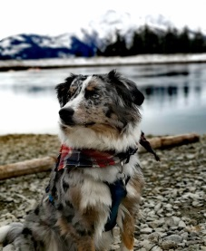
AUSTRALIAN SHEPHERD
He is a very friendly, playful and energetic dog. It is suitable for children. He learns various commands and instructions very quickly and likes to learn. He has a strong defensive instinct. He should treat animals and other people well. This dog is suitable for live outside, but he also gets used to life in the city.
History
This dog was bred in California from various other shepherds. It was used mainly for grazing sheep. Today it is also used as a rescue dog or companion. It needs a lot of movement. The beginnings of this breed are probably from the 16th - 17th century. This breed was legally recognized (Europe) in 2007.
Height
Height is measured at the withers. In dogs the preferred height is 51 cm - 58 cm and weight 25 kg - 29 kg, in bitches height 46 cm - 53 cm, weight 18 kg - 25 kg. Height should not be at the expense of quality.
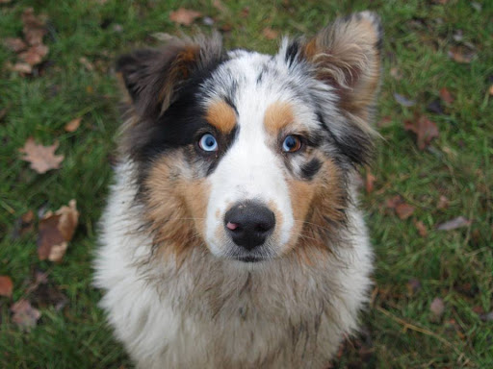
Nature
The Australian Shepherd is very selfless and always tries to help his master.Even in adulthood,he behaves like a small puppy and likes to play.It´s use mainly where livestock are kept.

