Meno: _________________________

Precvič si slovnú zásobu, pomôž si druhou stranou

_____________________

______________________

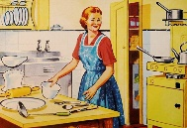___________________

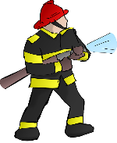____________________

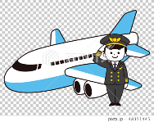___________________

_____________________

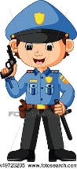______________________

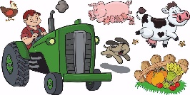_______________

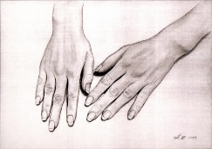_______________

______________

_______________________

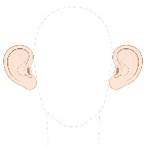________________________

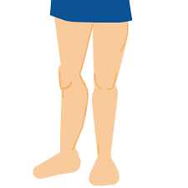_________________________

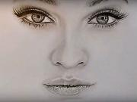_________________

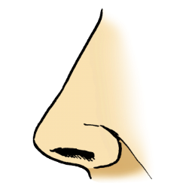_____________________

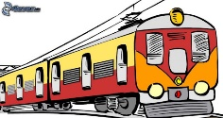______________________

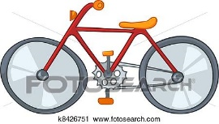_____________________

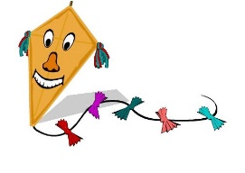____________________

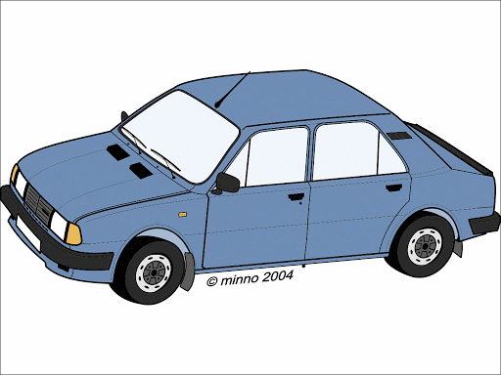______________________

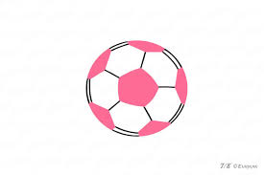______________________

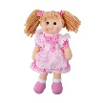__________________________

Meno: _________________________

___teacher__________________

______pupil________________

_housewife____________

___fireman______________

______pilot_____________

__doctor_________________

_____policeman______________

____farmer___________

_____hands__________

_eyes_____________

____fingers____________

_____ears__________

________legs___________

____face_______

_______nose________

_____train_________

______bike______

_____kite________

______car________

______ball__________

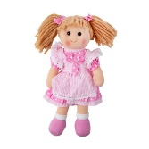________doll____________