Čítaj a prepíš mená detí krasopisne do celého riadku!
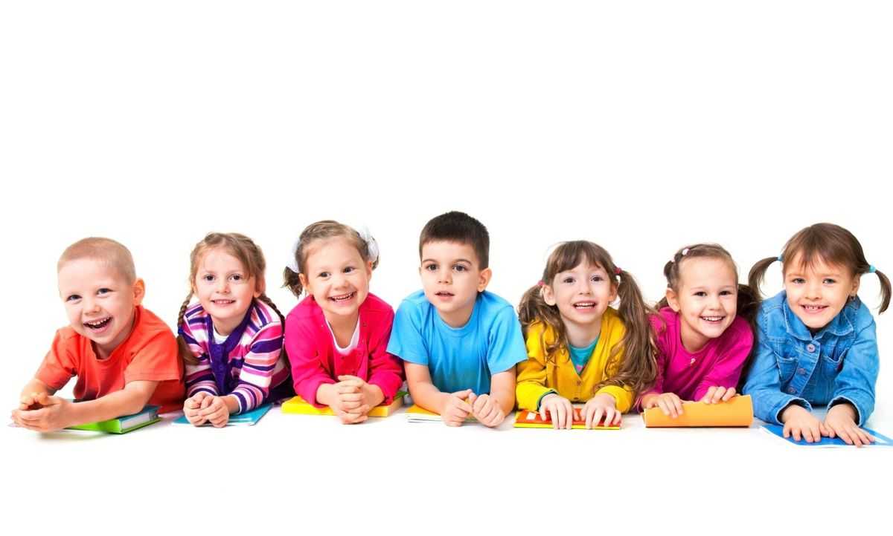

Lila___________________________________________________
Vilo ___________________________________________________
Milo ___________________________________________________
Jula_____________________________________________________
Eva _____________________________________________________
Vilma___________________________________________________
Emil____________________________________________________
Lolo____________________________________________________
Oto_____________________________________________________
Ula_____________________________________________________

